NEPAL COLLEGE OF INFORMATION TECHNOLOGY
Balkumari, Lalitpur
Affiliated to Pokhara University

LAB REPORT FOR EMBEDDED SYSTEMS


LAB REPORT 7: VHDL CODE FOR DE-MULTIPLEXER

Submitted by: Submitted to:
Name: Arpan Adhikari Er. Simanta Kasaju Roll No.: 231309
BE-CE (5th SEM)

S. N | LAB TOPIC | DATE | REMARKS
1. | VHDL Code (OR & AND Gate) | 20th Nov, 2025
2. | VHDL Code (OR & NOT Gate) using testbench | 23rd Nov
3. | Universal Gates and Special Gates | 30th Nov
4. | VHDL Code for Adder | 7th Dec
5. | VHDL Code for Subtractor | 14th Dec
6. | VHDL Code for Multiplexer | 21st Dec
7. | VHDL Code for De-Multiplexer | 4th Jan,  2026

LAB 7: VHDL CODE FOR DE-MULTIPLEXER

OBJECTIVE:
The objective of this lab is to understand the working principle of Demultiplexers by designing and implementing 1:4 and 1:8 Demultiplexer circuits using VHDL. This experiment aims to familiarize students with combinational logic design, select line operation, and VHDL coding techniques for data distribution circuits. It also helps in simulating and verifying the correct operation of demultiplexers for different input and select line combinations.

THEORY:

Introduction to Demultiplexer
A Demultiplexer (DEMUX) is a combinational digital circuit that takes a single input signal and routes it to one of several output lines based on the values of select lines. It performs the reverse operation of a multiplexer and is widely used in digital communication systems, data distribution, and control applications.

1:4 DEMULTIPLEXER
A 1:4 Demultiplexer distributes one input data line to one of four output lines using two select lines.

Inputs
- Data input: D
- Select lines: S1, S0

Outputs
- Y0, Y1, Y2, Y3

Working Principle
Based on the binary value of the select lines, the input data is transferred to the corresponding output line, while the remaining outputs stay at logic zero.

Logic Equations
- Y0 = D · S̅1 · S̅0
- Y1 = D · S̅1 · S0
- Y2 = D · S1 · S̅0
- Y3 = D · S1 · S0

Truth Table
S1 | S0 | Active Output
0 | 0 | Y0
0 | 1 | Y1
1 | 0 | Y2
1 | 1 | Y3

1:8 DEMULTIPLEXER
A 1:8 Demultiplexer routes a single input data line to one of eight output lines using three select lines.

Inputs
- Data input: D
- Select lines: S2, S1, S0

Outputs
- Y0, Y1, Y2, Y3, Y4, Y5, Y6, Y7

Working Principle
Each unique combination of select lines activates only one output line, allowing the input data to appear at that output.

Logic Equations

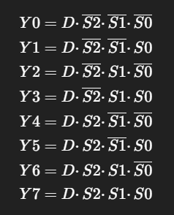

Truth Table
S2 | S1 | S0 | Active Output
0 | 0 | 0 | Y0
0 | 0 | 1 | Y1
0 | 1 | 0 | Y2
0 | 1 | 1 | Y3
1 | 0 | 0 | Y4
1 | 0 | 1 | Y5
1 | 1 | 0 | Y6
1 | 1 | 1 | Y7

Demultiplexer Implementation Using VHDL
VHDL (VHSIC Hardware Description Language) is used to model demultiplexer circuits using concurrent signal assignments or case statements. The select lines determine which output receives the input data. Simulation of the VHDL code helps verify the correct functionality of the demultiplexer for all possible input and select combinations.
1:4 DEMUX

DATAFLOW FOR 1:4 DEMUX:

library IEEE;
use IEEE.std_logic_1164.all;

entity arpdeMux is
port(
I : in std_logic;
S : in std_logic_vector(1 downto 0);
Y : out std_logic_vector(3 downto 0)
);
end arpdeMux;

architecture arch_arpdeMux of arpdeMux is
begin
Y(0) <= I and not S(0) and not S(1);
Y(1) <= I and S(0) and not S(1);
Y(2) <= I and not S(0) and S(1);
Y(3) <= I and S(0) and S(1);
end arch_arpdeMux;

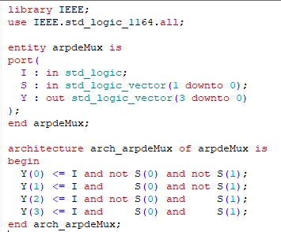

BEHAVIORAL FOR 1:4 DE-MUX:

library IEEE;
use IEEE.std_logic_1164.all;

entity arpdeMux is
port(
I : in std_logic;
S : in std_logic_vector(1 downto 0);
Y : out std_logic_vector(3 downto 0)
);
end arpdeMux;

architecture arch_arpdeMux of arpdeMux is
begin
process (I,S)
begin
Y <= "0000";

case S is
when "00" => Y(0) <= I;
when "01" => Y(1) <= I;
when "10" => Y(2) <= I;
when "11" => Y(3) <= I;
when others => Y <= "0000";
end case;
end process;
end arch_arpdeMux;
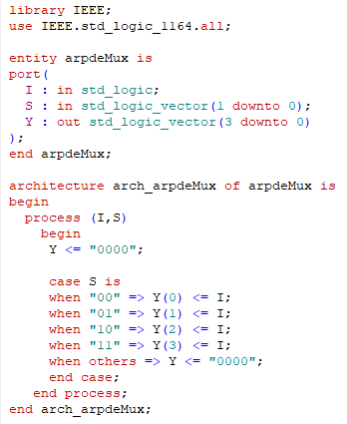
TESTBENCH FOR 1:4 DE-MUX:

library IEEE;
use IEEE.std_logic_1164.all;

entity test_arpdemux is
end entity;

architecture arch_demuxarp of test_arpdemux is

component arpdeMux
port(
I : in std_logic;
S : in std_logic_vector(1 downto 0);
Y : out std_logic_vector(3 downto 0)
);
end component;

signal I : std_logic;
signal S : std_logic_vector(1 downto 0);
signal Y : std_logic_vector(3 downto 0);

begin
UUT: arpdeMux port map
(
I => I,
S => S,
Y => Y
);

stim_proc: process
begin

I <= '0';
S <= "00"; wait for 100 ps;
S <= "01"; wait for 100 ps;
S <= "10"; wait for 100 ps;
S <= "11"; wait for 100 ps;
I <= '1';
S <= "00"; wait for 100 ps;
S <= "01"; wait for 100 ps;
S <= "10"; wait for 100 ps;
S <= "11"; wait for 100 ps;
end process;
end arch_demuxarp;

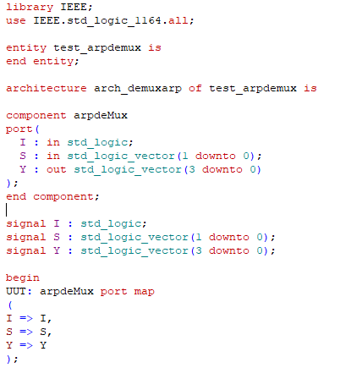
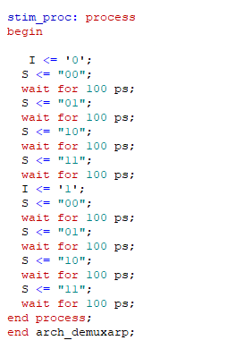

WAVEFORM FOR 1:4 DEMUX:

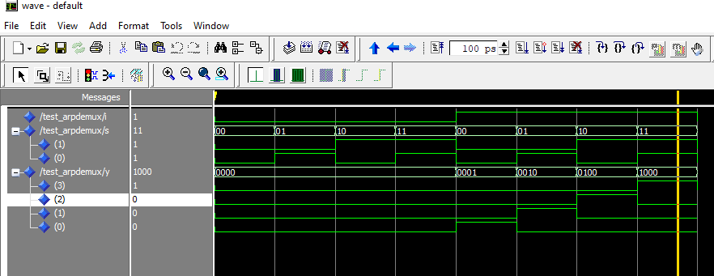

1:8 DEMUX

DATAFLOW FOR 1:8 DEMUX:

library IEEE;
use IEEE.std_logic_1164.all;

entity arpdeMux is
port(
I : in std_logic;
S : in std_logic_vector(2 downto 0);
Y : out std_logic_vector(7 downto 0)
);
end arpdeMux;

architecture arch_arpdeMux of arpdeMux is
begin
Y(0) <= I and (not S(0)) and (not S(1)) and (not S(2));
Y(1) <= I and (not S(0)) and (not S(1)) and ( S(2));
Y(2) <= I and (not S(0)) and ( S(1)) and (not S(2));
Y(3) <= I and (not S(0)) and ( S(1)) and ( S(2));
Y(4) <= I and ( S(0)) and (not S(1)) and (not S(2));
Y(5) <= I and ( S(0)) and (not S(1)) and ( S(2));
Y(6) <= I and ( S(0)) and ( S(1)) and (not S(2));
Y(7) <= I and ( S(0)) and ( S(1)) and ( S(2));
end arch_arpdeMux;

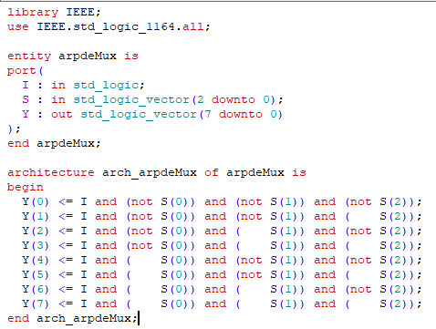

BEHAVIORAL FOR 1:8 MUX:

library IEEE;
use IEEE.std_logic_1164.all;

entity arpdeMux is
port(
I : in std_logic;
S : in std_logic_vector(2 downto 0);
Y : out std_logic_vector(7 downto 0)
);
end arpdeMux;

architecture arch_arpdeMux of arpdeMux is
begin
process (I,S)
begin
Y <= "00000000";

case S is
when "000" => Y(0) <= I;
when "001" => Y(1) <= I;
when "010" => Y(2) <= I;
when "011" => Y(3) <= I;
when "100" => Y(4) <= I;
when "101" => Y(5) <= I;
when "110" => Y(6) <= I;
when "111" => Y(7) <= I;
when others => Y <= "00000000";
end case;
end process;
end arch_arpdeMux;

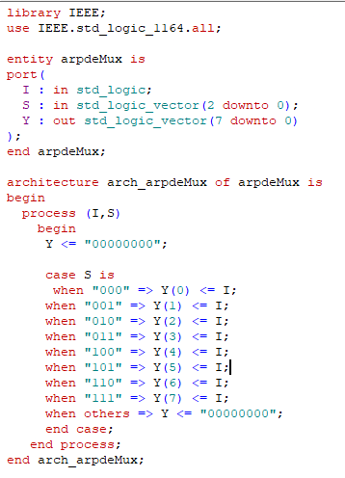

TESTBENCH FOR 1:8 DEMUX:

library IEEE;
use IEEE.std_logic_1164.all;

entity test_arpdemux is
end entity;

architecture arch_demuxarp of test_arpdemux is

component arpdeMux
port(
I : in std_logic;
S : in std_logic_vector(2 downto 0);
Y : out std_logic_vector(7 downto 0)
);
end component;

signal I : std_logic;
signal S : std_logic_vector(2 downto 0);
signal Y : std_logic_vector(7 downto 0);

begin
UUT: arpdeMux port map
(
I => I,
S => S,
Y => Y
);

stim_proc:process
begin
I<='0';
S<="000"; wait for 100 ps;
S<="001"; wait for 100 ps;
S<="010"; wait for 100 ps;
S<="011"; wait for 100 ps;
S<="100"; wait for 100 ps;
S<="101"; wait for 100 ps;
S<="110"; wait for 100 ps;
S<="111"; wait for 100 ps;
I<='1';
S<="000"; wait for 100 ps;
S<="001"; wait for 100 ps;
S<="010"; wait for 100 ps;
S<="011"; wait for 100 ps;
S<="100"; wait for 100 ps;
S<="101"; wait for 100 ps;
S<="110"; wait for 100 ps;
S<="111"; wait for 100 ps;
end process;
end arch_demuxarp;

WAVEFORM FOR 1:8 DEMUX:

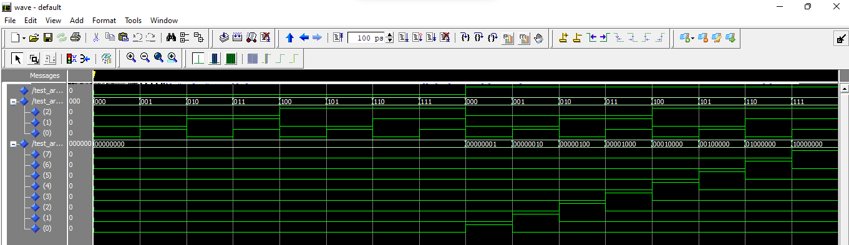

RESULT:
The 1:4 and 1:8 Demultiplexer circuits were successfully designed and implemented using VHDL. Simulation was performed for all possible combinations of select lines and input data. The results showed that the input data was correctly directed to the selected output line, while all other output lines remained at logic zero. The observed simulation waveforms matched the theoretical truth tables, confirming the correct operation of both demultiplexer circuits.

CONCLUSION:
In this experiment, the functionality of 1:4 and 1:8 Demultiplexers was successfully studied and verified using VHDL. The experiment improved understanding of data distribution controlled by select lines and demonstrated the importance of demultiplexers in digital systems. The simulation results were in complete agreement with theoretical expectations, proving the correctness of the VHDL implementation. This experiment provides a strong foundation for implementing data routing and control logic in complex digital designs.

